Q1

1)

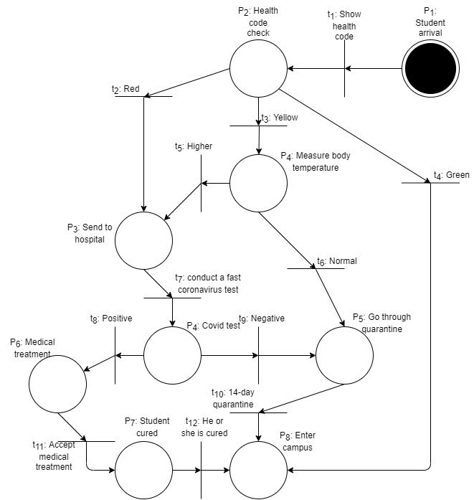

A possible firing sequence: t1 🡺 t4

2)

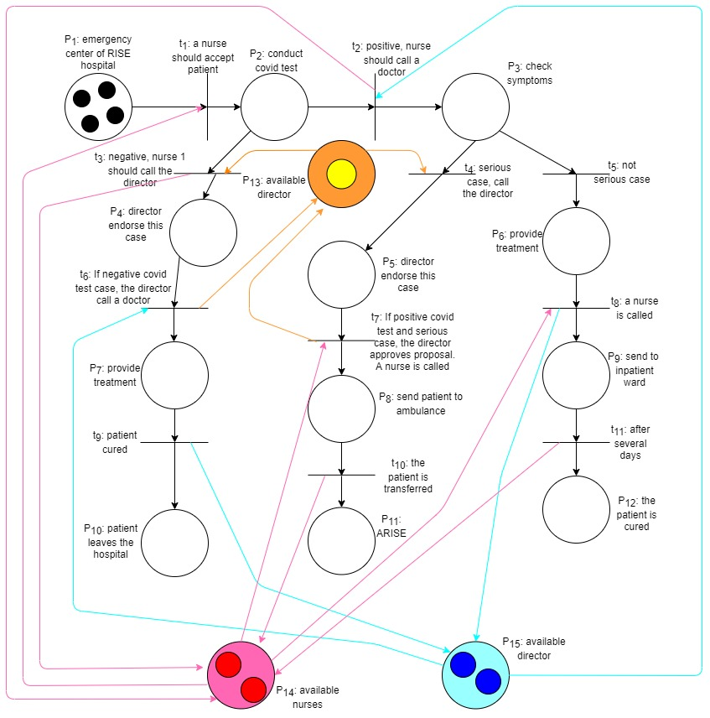

A possible firing sequence: t1 🡺 t3 🡺 t6 🡺 t9

Q2

1)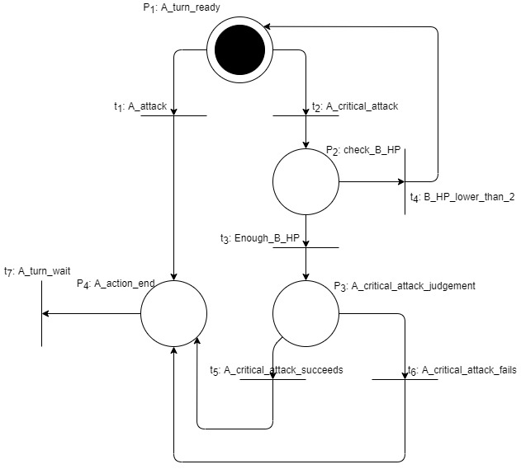

A possible firing sequence: t1 🡺 t7

2)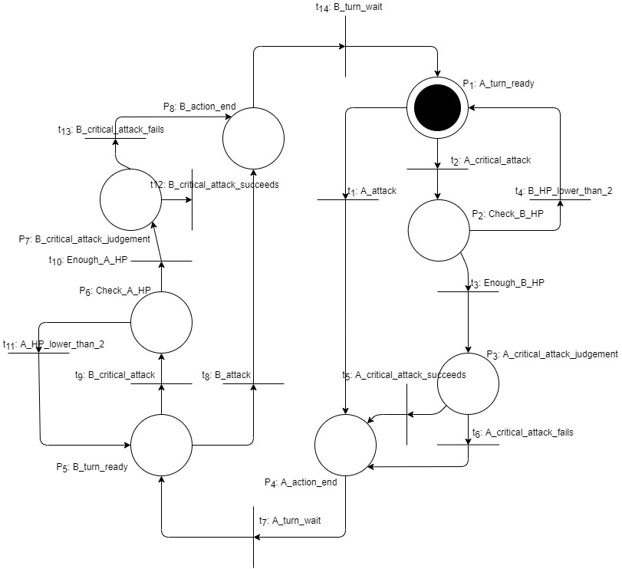

A possible firing sequence: t1 🡺 t7 🡺 t8 🡺 t14

3)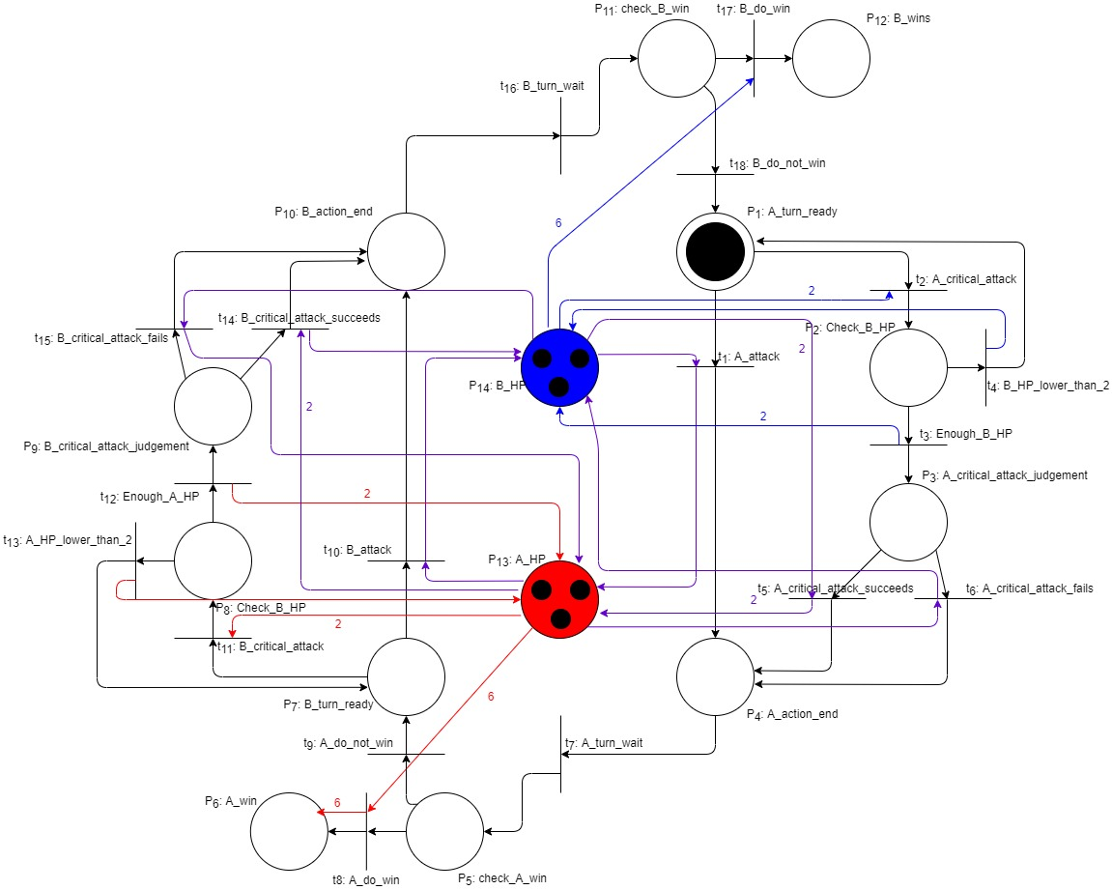

Q3

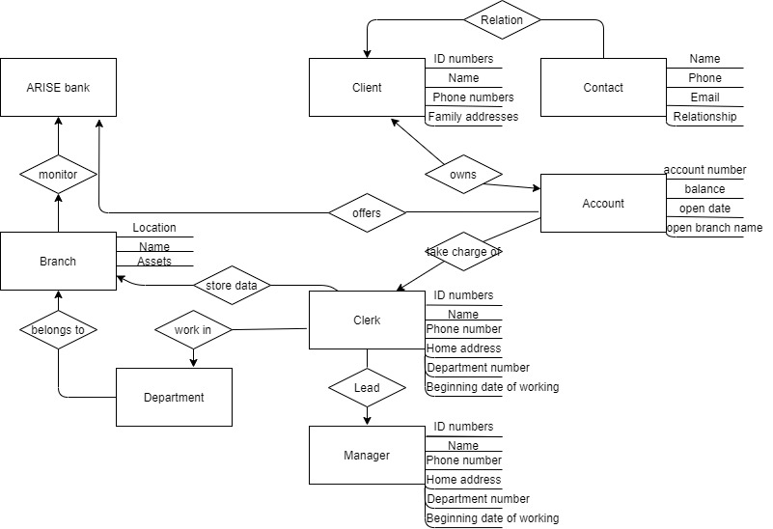

Q4

1)

a) For sequence NBBS, valid_sequence(1, 4) always returns false.

b) For sequence NNNSBNSBBS, valid_sequence (1, 10) always returns false.

c) For sequence NNNSNNSNNSNNSNNSNNSNNSNNS, valid_sequence(1, 25) returns true at some time.

1st: c = 3. The values of x, y, i, j are 2, 4, 5, 10 respectively.

2nd: c = 3. The values of x, y, i, j are 5, 7, 8, 13 respectively.

3rd: c = 3. The values of x, y, i, j are 8, 10, 11, 16 respectively.

4th: c = 3. The values of x, y, i, j are 11, 13, 14, 19 respectively.

5th: c = 3. The values of x, y, i, j are 14, 16, 17, 22 respectively.

d) For sequence NNBSBBBBS, valid_sequence (1, 10) always returns false.

e) For sequence NNBSNBSBBSBNSBBSBBSBBS, valid_sequence (1, 22) always returns false.

f) For sequence NNBSNNSBBSNBSBBSBBSBBSNNSBBSBBSBBSBBSBBSBBSBBS, valid_sequence (1, 46) always returns false.

2)

valid_sequence(m, n) just let the sequence starting with “NNN”, repeating “SNN” passes through.

valid_layer(x, y, i, j) blocks the sequence not satisfying the condition.